Hạn nộp: tuần 10 (July 31st, 2020)
Một bản in màu Ấn Phẩm Đặc Biệt dành cho trẻ em Chào Hè 2020
Đối tượng độc giả: học sinh tiểu học Việt Nam

“Hello Summer 2020”

- Lời nhà xuất bản/tác giả  - Bản tin (ít nhất 3 mẩu tin)  - Câu chuyện học đường  - Truyện tranh  - Bài hát (có khuông nhạc)  - Câu đố  - Ô chữ  - Góc sáng tạo  - Góc hài hước (3-4 mẩu chuyện vui)  - Trải nghiệm và khám phá | • Foreword  • Interesting news  • Education story  • Odd comic friends  • Voice of the wind  • Quizizz quizizz  • Crossword puzzle  • Creative place for you  • Amusing story  • Experiencing and discovering

(Tự chọn)
Loan: phần:4,5,7
Thảo: phần: 9, 10
Thương: phần: 3,8
Cúc: phần: 1, 2, 6
- Foreword (lời nhà xuất bản)
Dear lovely children,
Since ancient times, books have always been a great friend for all of us because they contain immense knowledge of humanity. Every time we read a book, we enter a world of interesting, useful and wonderful things like never before that we can understand more of the world out there. Human knowledge is the ocean, our knowledge is just like a drop of water. So reading is a really good chance if we want to expand our comprehension.
Because we, publishers, were also kids, we understand what you want and like. We are especially publishing a special magazine for you this summer. "Hello Summer 2020" is a children's publication with interesting articles, creative puzzle games, funny stories and a variety of fascinating topics that you should not miss.
We hope that our "Hello Summer 2020" will not only bring knowledge but also help children have moments of relaxation and create their own creative products. Wishing you all good study and fulfill your dreams.

- Interesting news (bản tin)
- New Zealand offers 18 scholarships to Vietnamese students
Education New Zealand (ENZ) announced the next round of New Zealand Schools Scholarships (NZSS) 2020, with 18 scholarships offered to Vietnamese students to study in New Zealand’s prestigious secondary schools.
Students can apply for the next round from July 6 to August 31. The scholarship is aimed at bringing about more opportunities for Vietnamese students to experience the high-quality education of New Zealand.
Each scholarship provides a 50% subsidy on the school tuition fees for the first year of study. Applicants are required to submit their academic records, English certificate and a 1.5-minute-long video highlighting why they should be chosen to win the NZSS.
“We’re very happy to be launching the second round of applications for 2020. This decision was taken following feedback from our education agent partners as well as the interest from Vietnamese students and parents who are still looking for the right scholarship opportunity in New Zealand. When the time is right, we look forward to welcoming the scholarship winners to New Zealand and into our exceptional secondary schools,” Ben Burrowes, Education New Zealand’s Regional Manager for East Asia, said in a statement.
ENZ announced 22 winners of the first round of the NZSS 2020, with recipients being offered a 50% cut on their tuition fees for the first year of study in New Zealand. One student was specially handpicked to win the only 100% scholarship for her highly impressive application.
The second year of the NZSS saw tremendous interest from Vietnamese students. Applications have been sent from across the country, all of which are from passionate and talented students.
- Australian-funded online course helps Vietnamese teachers improve English proficiency
Australia’s Quality Training Solutions organization is providing an online English course for teachers at several universities in Vietnam to help them improve English proficiency and technology access.
This English program is carried out under the promotion of Aus4 Skills and Australian Awards and expected to contribute to improving the quality of global education.
Over 100 teachers at Tay Bac University, Thai Nguyen University, and Thai Nguyen University of Agriculture and Forestry are participating in the 12-month-long course.
“It is a very good opportunity for Tay Bac University. I believe that together with other efforts, this online course will help improve the level of English of our staff and lecturers significantly,” said Doan Duc Lan, vice rector of the university.
“The course is designed in an attractive way. […] It has motivated our lecturers and staff in learning English. People have created a group to share and exchange information with each other and they are quite active in that group,” said Quyen, Aus4skills coordinator at Tay Bac University.
“Quality Training Solutions professors hope the program will provide a long-term international English learning environment and modern distance learning technology, especially for lecturers in remote areas, to eliminate the geographical distance to study with the world,” said Trang Tran, chief representative of Quality Training Solutions.
This online English program is sponsored by the Australian Professors’ Study Encouragement Fund for Vietnam, according to Australian Alumni in Vietnam.
Founded by Australian professors and Australian alumni, Quality Training Solutions delivers quality education and training programs that give students the chance to create a positive future for themselves in the form of employment, career advancement and pathways to further education and self-development.
- HCMC library receives Mexican bookshelf
Mexican Honorary Consul Vu Minh Anh handed over a bookshelf of Mexican book titles to Vinh Quoc Bao, deputy director of General Science Library of HCMC in District 1, on Monday, July 13. The activity is to celebrate the 45th anniversary of diplomatic relations between Mexico and Vietnam.
The bookshelf features books about Mexican history, literature, culture and people, and most of them are in Vietnamese. The bookshelf supported by the Mexican Embassy and Consulate in Vietnam will be updated with 50 to 100 new books every year, said Mexican Honorary Consul Vu Minh Anh. It is also expected to promote the Mexican culture to those interested in Spanish as well as the culture of South America. Moreover, Mexican film screening events and cultural exchange sessions will take place at the library in the coming time.
Vu Quoc Bao, general director of the library, said that prior to this bookshelf, the library had worked with embassies and consulates of other countries such as Germany, France, Japan, etc. to introduce books about these countries to readers. On the occasion, the library will update these bookshelves to meet the demand of readers.
The General Science Library of HCMC, one of the biggest libraries in southern Vietnam, attracts around 400 to 1,000 people every day, who are both locals and foreigners, with 80% of them being students.

- Education story (câu chuyện học đường)
The teacher and the old bills
900,000 dong, he kept on fumbling old 10,000 dongs and wanted a corner with no one to cry. Finally, he passed the university. The first person he wanted to announce this important news about was not his father or his mother but his beloved teacher ...

His family is poor, crowded with many brothers and sisters, and his hometown is poor, so few people dare to think about sending their children to university for a long time. The same goes for their parents, partly because they are too poor, partly because they think about their children's condition "how to fight against people". He is the only one who supports it, giving him the belief that "he can". Happiness was short-lived, so much anxiety swarmed around it ... Five years, hundreds of money like bees buzzed in his head. Then the teacher came to bring him a batch of books, which he guessed were his "etiquette" lessons, put a small package in his hand, and told him to be a "secret" and told him only when it was difficult. The most newly opened. It was not an "alert" excess. The "secret" package that when he received it from his teacher suspected that it was a bunch of 10,000 VND bills wrapped in two old layers of plastic, the smoothly flattened bills that he believed he had put away for a long time! 900,000 dong, he kept on fumbling old 10,000 dongs and wanted a corner with no one to cry. It has been two years since the day the wanderer came to Saigon to visit her, throw in his hands hard 10,000 dongs, and hurried back. The teacher moves to another place after then. Two years, sometimes he still received the money of the teacher 10,000 (strange, again at times it seems most deadlock!) ... Two years, it has not once visited him. At noon, after returning from school, my mother reported to the newspaper: "Mr. H. is dead!" He stammered and asked only three words: "Why did you die?", Then collapsed when his mother choked on the other end of the line: "You have been ill for a long time and no one knows. The day he took him to the hospital, the doctor took a picture to know that he was completely corrupted and the five organs were gone. He put away all the getting on the bus. In the hot afternoon tunnel bustling with car sickness, he saw the gentle teacher coming to him, pressing his hot hands with sparkling 10,000 dong notes ...

Only now did he notice that the teacher was very pale, the skillful hands of the old days were so much cloaked ... He suddenly woke up, tears rolled down his cheeks, his heart sobbed: " Teacher ... why don't you wait for me to come back ... !? ". Because he kept thinking: if he exchanged those 10,000 dongs for medicine, he would live until he could return.

- Odd comic friends (truyện tranh)

- Voice of the wind (bài hát)
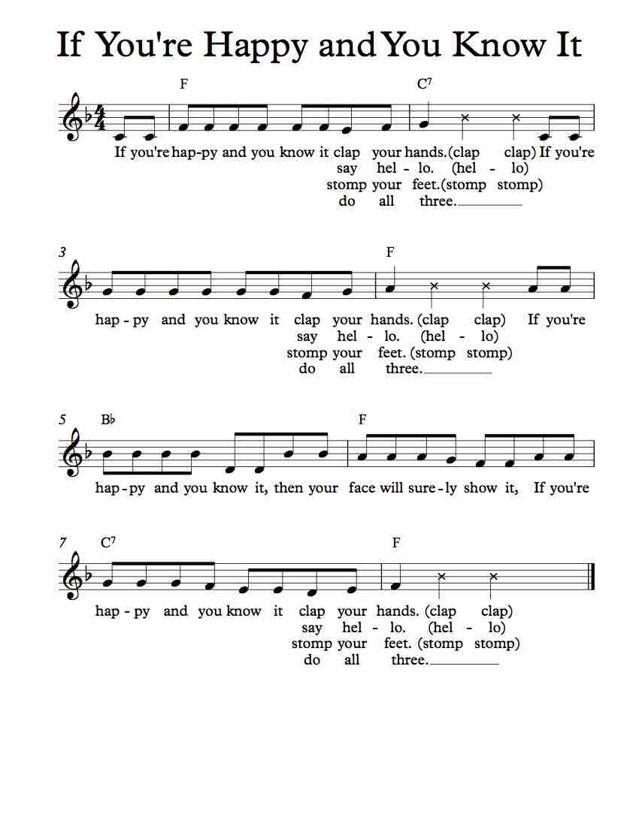
- Quizizz quizizz (câu đố)
1. What has to be broken before you can use it?
-> An egg
2. I’m tall when I’m young, and I’m short when I’m old. What am I?
-> A candle
3. What month of the year has 28 days?
-> All of them
4. What is full of holes but still holds water?
-> A sponge
5. What question can you never answer yes to?
-> Are you asleep yet?
6. What goes up but never comes down?
-> Your age
7. A man who was outside in the rain without an umbrella or hat didn’t get a single hair on his head wet. Why?
-> He was bald.
8. What gets wet while drying?
-> A towel
9. I have branches, but no fruit, trunk or leaves. What am I?
-> What can’t talk but will reply when spoken to?
-> An echo
- Crossword puzzle (giải ô chữ)
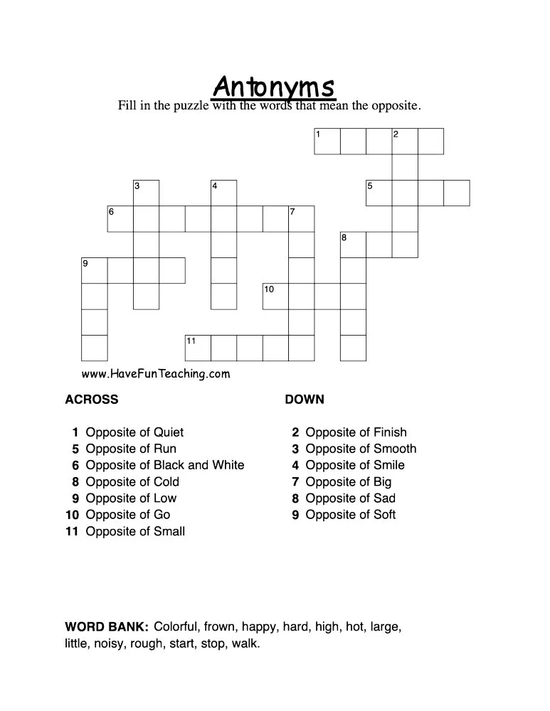
- Creative place for you (góc sáng tạo)
How to make flower baskets with plastic bottles
1. Preparation
• One bottle of 1,5l. Coca Cola or pepsi bottle cover for convenience!
• Colorful fabrics
• Lacing fabric, wire cloth
• Scissors, knifes
• Regular adhesive, brush
•Glue Guns.
• A needle or hole puncher
2. Implementation
Step 1:

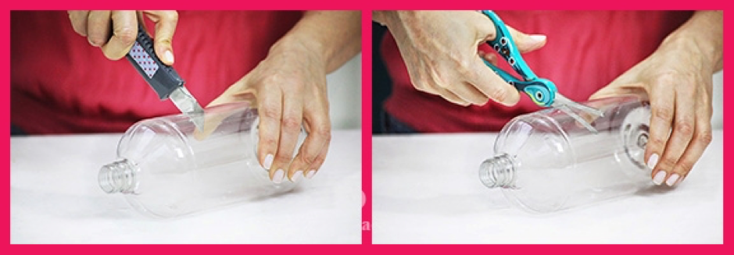
Use a knife to cut the bottle
Use a knife to make an incision across the bottle and then cut along the incision.
Step 2:
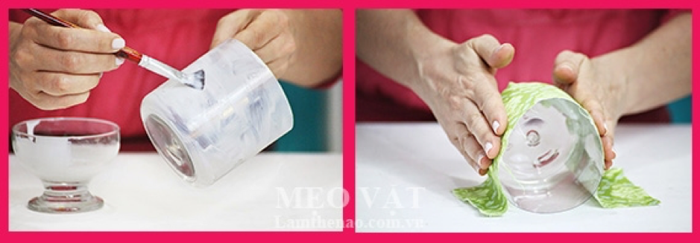
Apply the glue evenly and then cover the fabric
Cut a piece of cloth about 30 × 25 cm in size, sweep the milk glue evenly on the outside of the bottle and then rub the cloth firmly on the surface of the bottle with your fingers so that the fabric will stick tightly.
Step 3:

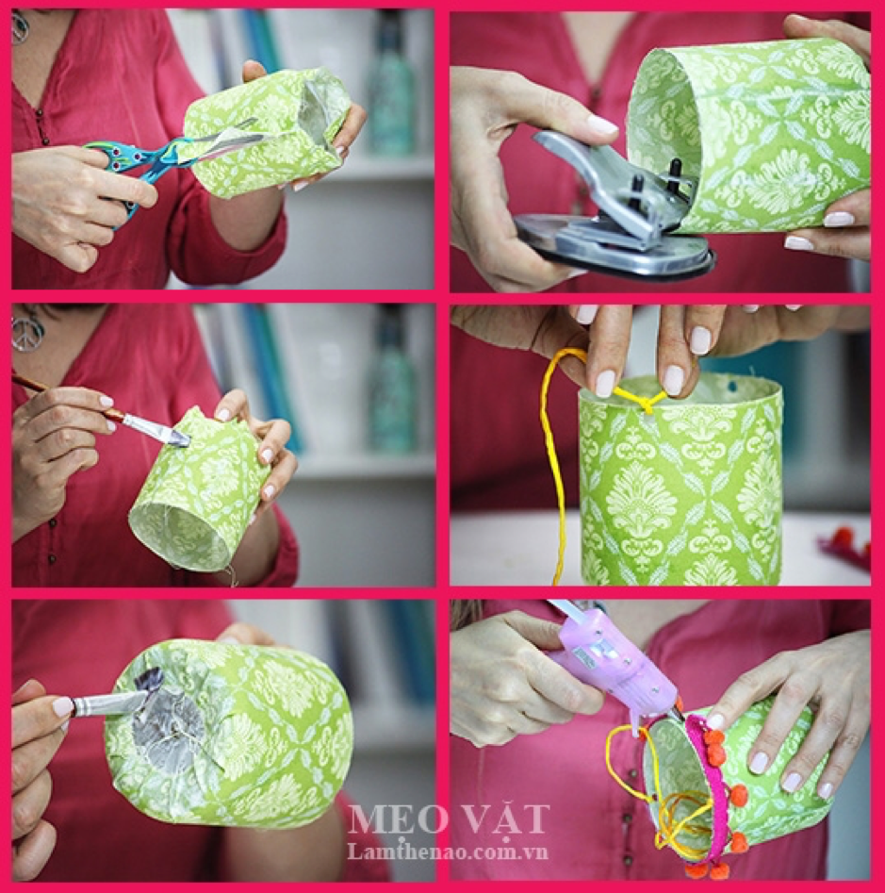

Wrap cloth and glue
Wait for the glue to dry, take the scissors to cut away the excess cloth. To prevent the seams from being exposed and to avoid the excess fibers, apply glue to the cut area. The excess fabric is folded round to the bottom and then glued.
Step 4: Use a very hot needle and then skewer into the mouth of the bottle located on either side, or to be safe, you can use the 2-hole punch pliers to 2 sides of the mouth.
Step 5: Finally, put the pretty little flowers in the plastic bottle and hang on the balcony.

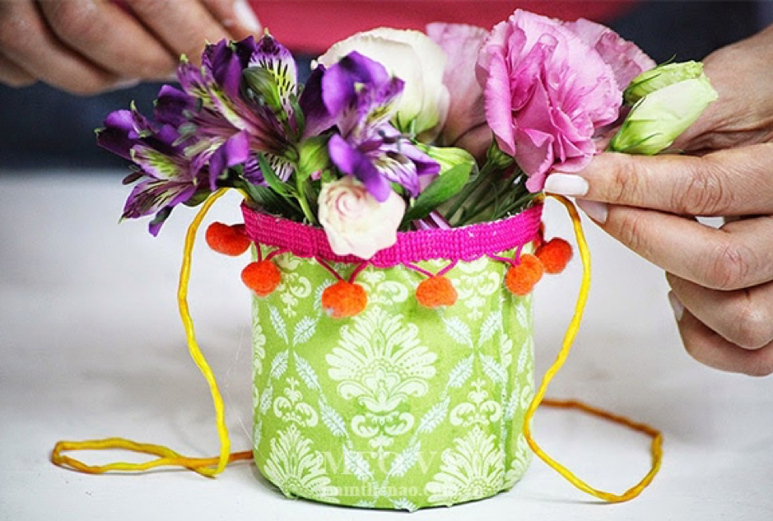
Lovely flower baskets from plastic bottles

- Amusing story (truyện vui)
- You’re smarter already
A customer at Green's Gourmet Grocery marveled at the proprietor's quick wit and intelligence. "Tell me, Green, what makes you so smart?"

"I wouldn't share my secret with just anyone," Green replies, lowering his voice so the other shoppers won't hear. "But since you're a good and faithful customer, I'll let you in on it. Fish heads.

You eat enough of them, you'll be positively brilliant."

"You sell them here?" the customer asks.

"Only $4 apiece," says Green.

The customer buys three. A week later, he's back in the store complaining that the fish heads were disgusting and he isn't any smarter.

"You didn't eat enough, " says Green. The customer goes home with 20 more fish heads. Two weeks later, he's back and this time he's really angry.

"Hey, Green," he says, "You're selling me fish heads for $4 apiece when I can buy the whole fish for $2. You're ripping me off!"

"You see?" says Green. "You're smarter already."
- The best time for apples

It was the first lesson after the summer holidays at a small school. The lesson was about the seasons of the year, the teacher said:

“ They are Spring, Summer, Autumn and Winter. In Spring, it is warm and everything begins to grow. In Summer it is hot and there are many flowers in the fields and gardens. In Autumn there are many vegetables and many fruits. Everybody likes to eat fruit. In Winter it is cold and it often rains. Sometimes there is snow on the ground.”

Here the teacher stopped and looked at one of the pupils.

“ Stop talking, Tom,” he said. “ When is the best time for apples?”

“ It is when the farmer is not at home and there is no dog in the garden.” Answered Tom.
- Too much speeding
A police officer in a small town stopped a motorist who was speeding down Main Street.

“But, officer,” the man began, “I can explain”

“Just be quiet,” snapped the officer. “I’m going to let you cool your heels in jail until the chief gets back.”

“But, officer, I just wanted to say”

“And I said to keep quiet! You’re going to jail!”

A few hours later the officer looked in on his prisoner and said, “Lucky for you that the chief’s at his daughter’s wedding.He’ll be in a good mood when he gets back.”

“Don’t count on it,” answered the fellow in the cell. “I’m the groom.”

- Experiencing and discovering (trải nghiệm và khám phá)
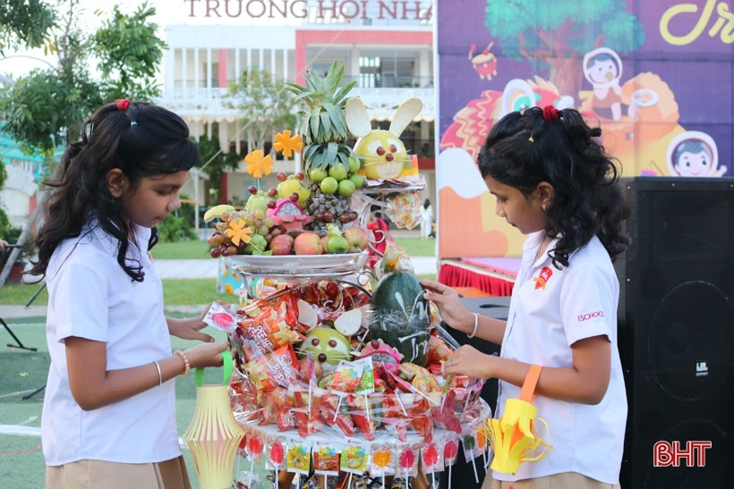
Although they have to leave their beloved homeland to go to Vietnam to live and work, but, for many foreign families in Ha Tinh, this is a time of interesting experiences, especially the Mid-Autumn Festival.
This year is the 8th year that Jyoti Koushal's family (India) came to Vietnam, the third year the family is attached to Ha Tinh. And every year, the Mid-Autumn Festival is always a special occasion for the whole family because only after coming to Vietnam, will Jyoti know what Tet is, the Tet looks for the moon.
In line with the new environment, Jyoti's twin daughters Niyati Koushal and Ayati Koushal have participated in traditional mid-autumn rituals at iSchool Ha Tinh International Integration School. There, the children played Vietnamese folk games, took part in the raiding, and carried the lights with their school friends. Not only that, Niyati and Ayati were also instructed by teachers on how to make traditional toys of Vietnam during the Mid-Autumn Festival.
Niyati Koushal shared: “I am very happy to welcome the Mid-Autumn Festival in Ha Tinh. This is interesting because in India there is no holiday like this, nor there are cakes like here. My friends at school are very cute, I am very happy to be able to pick the lights, break the dance, sing and dance with them during this holiday ”
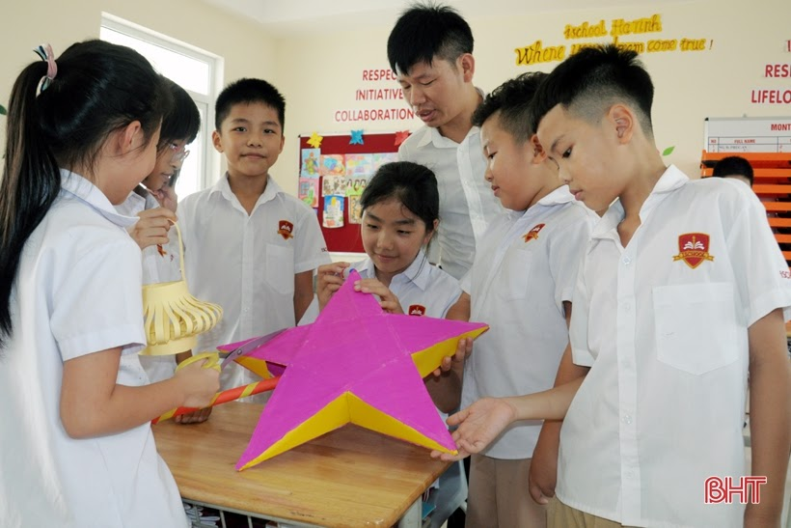
Bring the mood to explore as Niyati Koushal, younger brother Vuong Nhat Pham, from China, currently living and studying in Ha Tinh City, is always eager to look forward to the Mid-Autumn Festival. “China also has the Mid-Autumn Festival, but in Vietnam, I experience more interesting folk games. This is the second year Nhat Pham has received mid-autumn festival in Ha Tinh. At school, I also talked with her to prepare the tray, experience the steps to make moon cakes, so I'm happy. I have also witnessed the compassionate meanings of many organizations and individuals for disadvantaged children on this occasion, so the Mid-Autumn Festival in Vietnam for me is also a loving Tet ”- Vuong Nhat Pham share:

